Using My Ayrshire College
GUIDE FOR AYRSHIRE COLLEGE STUDENTS

Last Update: September 2021

Contents

Getting Started Page 3
Accessing My Ayrshire College Page 3
Your Logon Details Page 3
Logging in Page 4
Homepage Page 4
Key Features Page 5
Student Attendance Page 5
Student Absence Page 6
College Email Page 7
Student Information Page 7
MyLearning (Moodle) Page 8

GETTING STARTED

Ayrshire College has implemented a portal called ‘My Ayrshire College’ for students to be able to access information to support them whilst studying at college.

My Ayrshire College will provide students access to information on their course including subjects, results and attendance, myLearning (Moodle), induction, email, calendar, library information and much more.

ACCESSING MY AYRSHIRE COLLEGE
The service is accessible both internally and externally to the college. Access is provided by downloading the official My Ayrshire College app from the:

Apple Store http://bit.ly/myAyrshireiOS

or

Google Play Store http://bit.ly/myAyrshireGoogle

It can also be accessed via a standard web browser using the following url https://ayrshire.myday.cloud

Access to My Ayrshire College is provided for students who are enrolled at the college. Access will automatically be revoked should that membership change.

YOUR LOGON DETAILS
The same username and password you use to access the College network, will also be used to access My Ayrshire College. The format of your logon details are:

- Username (your student reference number), example – A12345678@ayrshire.ac.uk
- Password – your college network password or if you have not logged in before this will be your date of birth displayed as 6 numbers followed by Abc* (010182Abc*).

If you have issue accessing your network logon please see follow the guidance from ICT below https://www1.ayrshire.ac.uk/students/student-support/ict/

If you can access the college network but cannot access My Ayrshire College then please contact the support team for My Ayrshire College at the link below
https://www1.ayrshire.ac.uk/my-ayrshire-college/support/

LOGGING IN
My Ayrshire College can be accessed in any web browser using the link below or by using the Apple of Google apps
https://ayrshire.myday.cloud

You will be asked to authenticate.

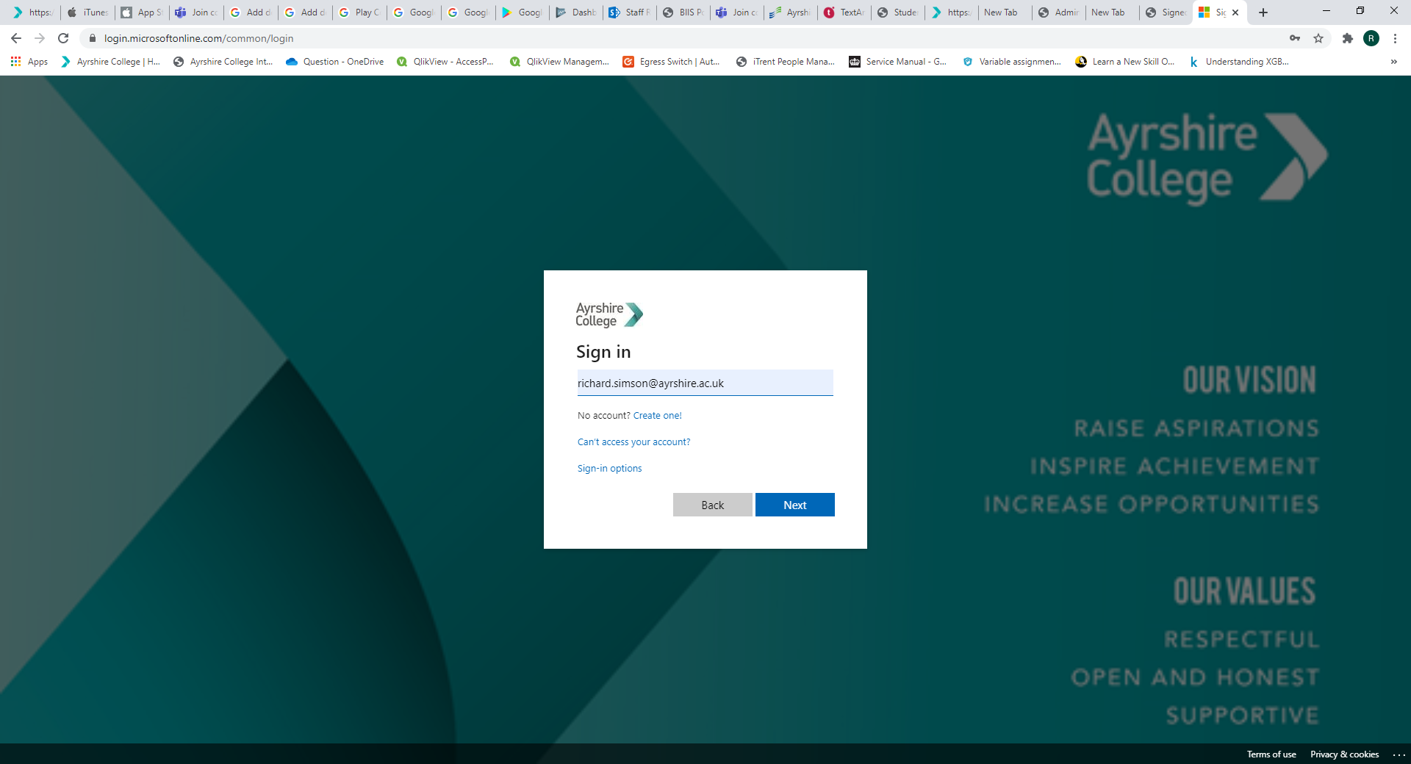

HOMEPAGE
The default homepage will initially be set to the Student Dashboard. Throughout the year, the Student Dashboard content frequently changes to support you as you study at college. We would suggest you regularly visit the app and check for new information.

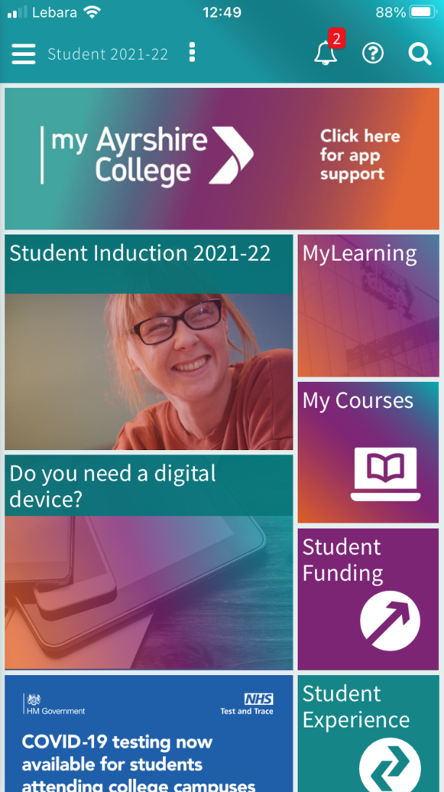
KEY FEATURES

Resources available from My Ayrshire College include:

    - Student Induction 2021-22
    - Application for Digital Support 2021-22
    - Latest Covid-19 information
    - Newsroom (latest information from the college)
    - Access to MyLearning (Moodle) courses
    - Access to college email
    - Access to your calendar
    - Access to your contact information, course information, attendance, and results
- Absence reporting (self-certification form processing)
    - Campus maps

and much more…

STUDENT ATTENDANCE

Students can access their attendance record by using the ‘Attendance’ tile. It will show all of the attendances throughout the year. Positive attendance marks are calculated based upon the criteria to claim for Student Funding (i.e. Bursary award). For example, when a self-certificate mark is submitted, this counts as a positive attendance although there was no actual physical attendance in the class. | 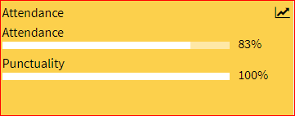

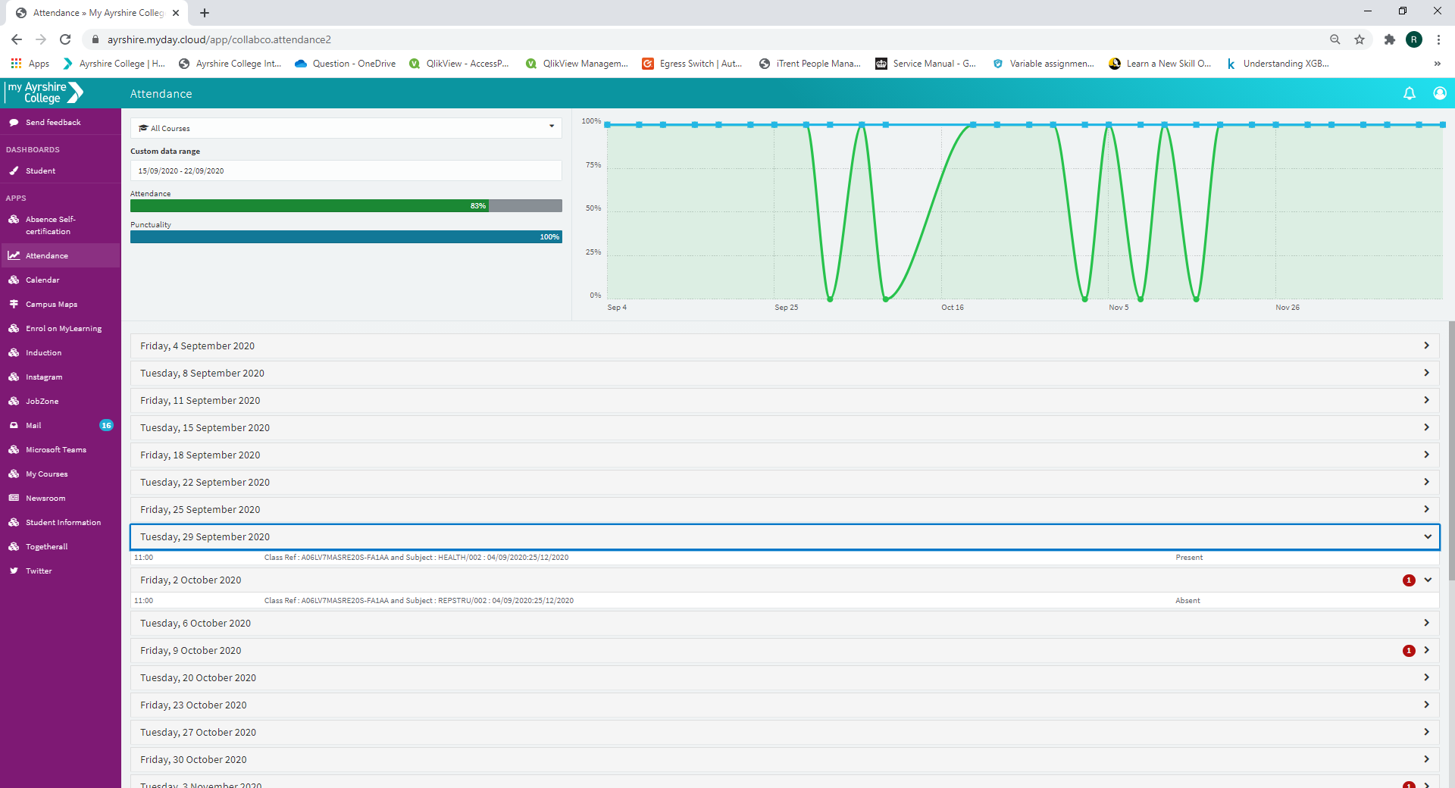

STUDENT ABSENCE
Self-certificates can be submitted using the ‘Absence’ tile and by completing the associated form
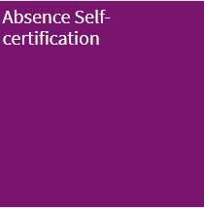 | 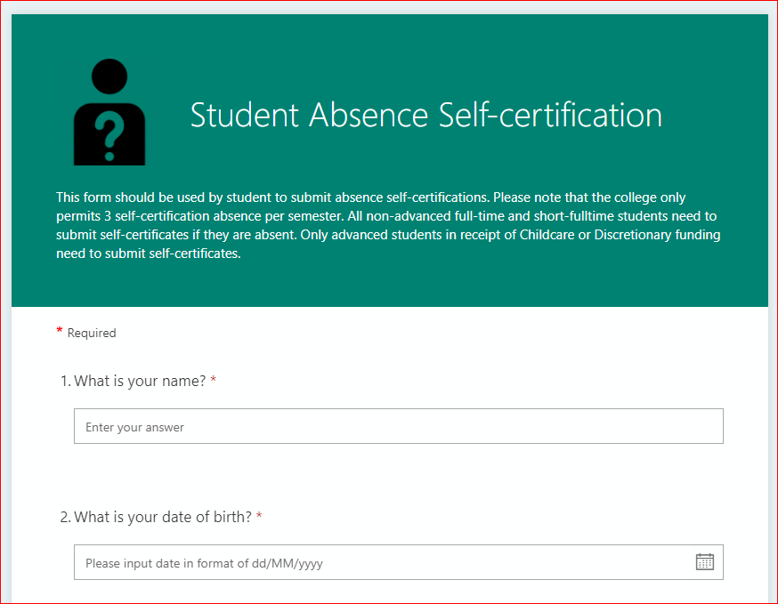

COLLEGE EMAIL

My Ayrshire College allows students to access their college email without having to login to a separate system. It has an inbuilt email client which can be used to read and send College email.
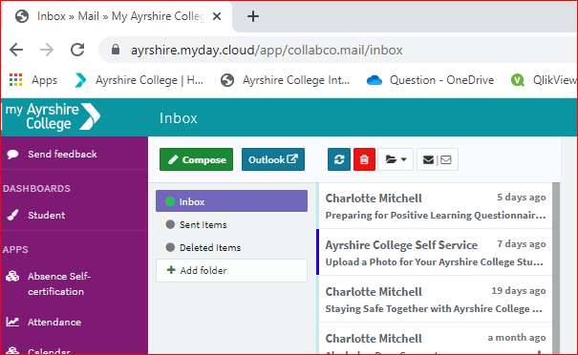

MY STUDENT INFORMATION
You can access your contact information, course information, attendance and results by using the student information tile. | 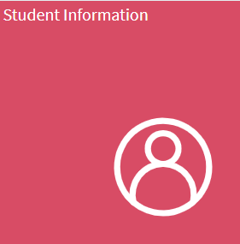
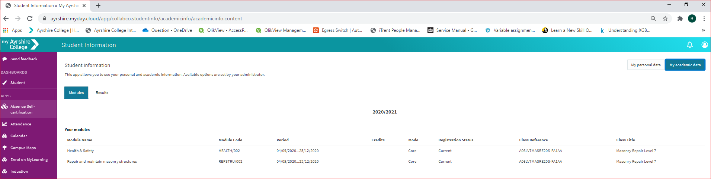
MYLEARNING (MOODLE)
You can access your Moodle course firstly by enrolling via the ‘My Learning Dashboard’ tile and then thereafter by accessing ‘My Learning Courses’.

