
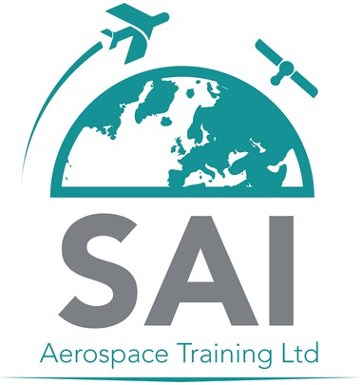
aircraft maintenance training
careerS

SAI Board Member Recruitment

Role Purpose and Remit

SAI Aerospace Training Ltd (SAI)

SAI Aerospace Training Limited (SC813576) is a private limited company established to deliver first class training and education in the aerospace sector. Based at Ayrshire College, the company was incorporated on 13 June 2024 and is looking to actively trade from August 2025.

The purpose of SAI Aerospace Training Limited is multifaceted:

- Educational Delivery
  - The company is structured to provide degree-level aerospace training, aligning with Ayrshire College’s broader educational mission.

- Operational Independence
  - It functions as a trading entity distinct from the College, allowing for more flexible commercial operations, including aircraft acquisition and financial planning.

- Governance and Compliance
  - The Board has been actively developing governance structures, including model articles of association and financial procedures manuals.

Board of Management Remit

The Board of Management of SAI will:
- Work at a senior level, maintaining and developing excellent corporate governance.
- Provide strategic leadership, vision, direction, support and guidance for SAI enabling the development of the corporate strategic vision, purpose, outcomes and goals, and ensure these are communicated effectively to industry stakeholders, customers and regulatory partners.
- Promote commitment to the corporate objectives to position SAI as a leading brand within the aerospace sector.
- Engage and communicate effectively and act as ambassadors and advocates for SAI with a wide range of stakeholders and industry and regulatory partners across the aerospace sector.
- Understand the context within which SAI operates, namely in terms of delivering high quality training and development to industry stakeholders.
- Ensure the overall proper functioning of SAI.
- Ensure the effective stewardship of SAI financial resources, through effective probity, planned investment and risk management.
- Promote collaborative working, engaging openly and inclusively with the Board, SAI leadership team and key stakeholders, enabling well-informed decision-making to deliver the corporate objectives.

Board Member Skills and Attributes

Skills and Experience | Descriptors
Demonstrate relevant industry knowledge and experience. | - Extensive knowledge of the aerospace industry/sector.  - Experience within a leadership role within the industry or operating as an industry specialist.  - Knowledge and awareness of the principles of effective governance.
Ability to work effectively in a team setting | - Work effectively with colleagues to deliver objectives.  - Actively seeks out the views of colleagues.  - Prepared to take on a task or role for the benefit of SAI.  - Will seek opportunities to build constructive relationships both within the organisation and with industry stakeholders and partners.
Ability to critically examine proposals and their supporting analysis | - Awareness of the key information required to make a decision.  - Sound evaluation of the information with a good range of conclusions being reached, which are clearly explained.  - Comfortable working with both numerical and written data.  - Track record of making decisions which have had a positive impact within an organisation.  - Using ‘hard’ evidence as well as seeking the views of others.  - Able to make decisions when the information available is complex and made up of several components which have to be analysed and assessed and may contain conflicting information or indicators.  - Able to think through the implications of decisions before coming to a final position
Constructive and supportive challenge –able to challenge without causing conflict. | - Direct evidence of challenging effectively within a diverse team or committee situation.  - Evidence of where challenge has changed the views of others and influenced decisions without causing rancor or resentment.  - Questioning shows good level of understanding of organisational and other issues that have led people to form their views.

Terms of Appointment

The posts are non-remunerated and are expected to require a commitment in the region of eight days per year. Reasonably incurred expenses in carrying out the role and remit will be reimbursed.

